**Analysing Housing Prices in Metropolitan areas in India – Report.**

1. **Introduction.**

**1.1 Overview**

**Analysing housing prices in metropolitan areas in India is a complex and multifaceted topic. Here’s a breif discription, Housing Prices can vary significanty across differentt metropolitan areas, with cities like Mumbai, Delhi, and Bangalore often having higher real estate costs compared to smaller metros. In Summary, ana housing prices in Indian metropolitan areas involves examining the complex interplay of economic, socil and policy factors that impact the real estate market, making it a vital area of study and concern for both residents and investors.**

**1.2 Purpose**

**economic and social Housing prices analysis can be used to gauge the quality of life in different areas and the accessibility of amenities. In esscence, analyzing housing prices serves a broad range of purposes, from informing individual decisions to shaping government policies and contributing to a deeperr underrstanding of the fabric of a region.**

1. **Problem Definition and Design Thinking**
   1. **Empathy Map**

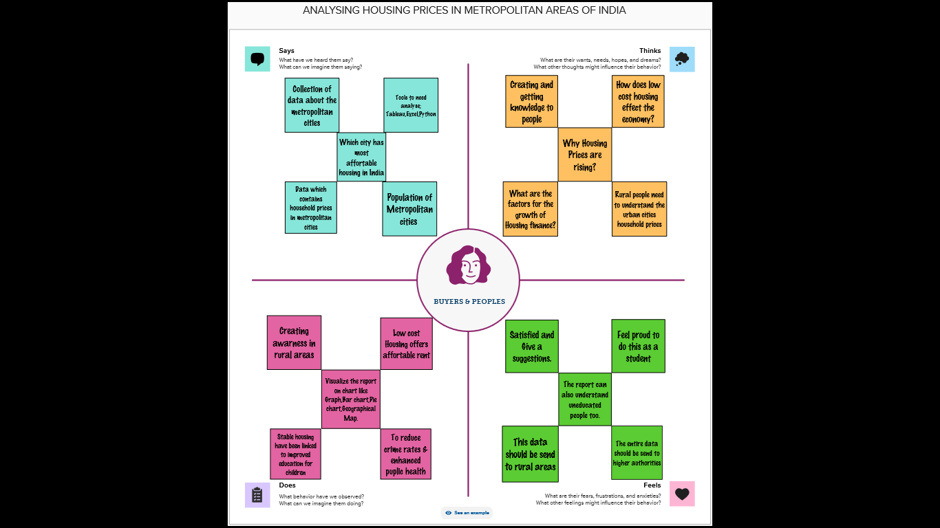

**2.2 Ideation and Brainstroming Map**

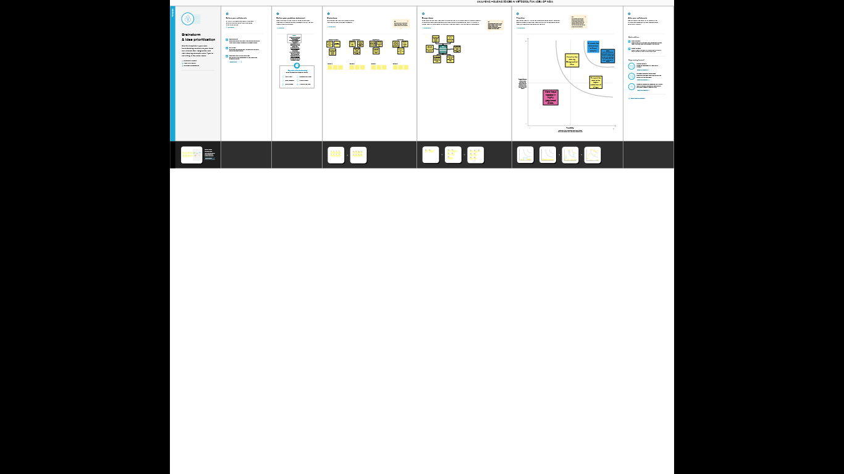

1. **Result:**

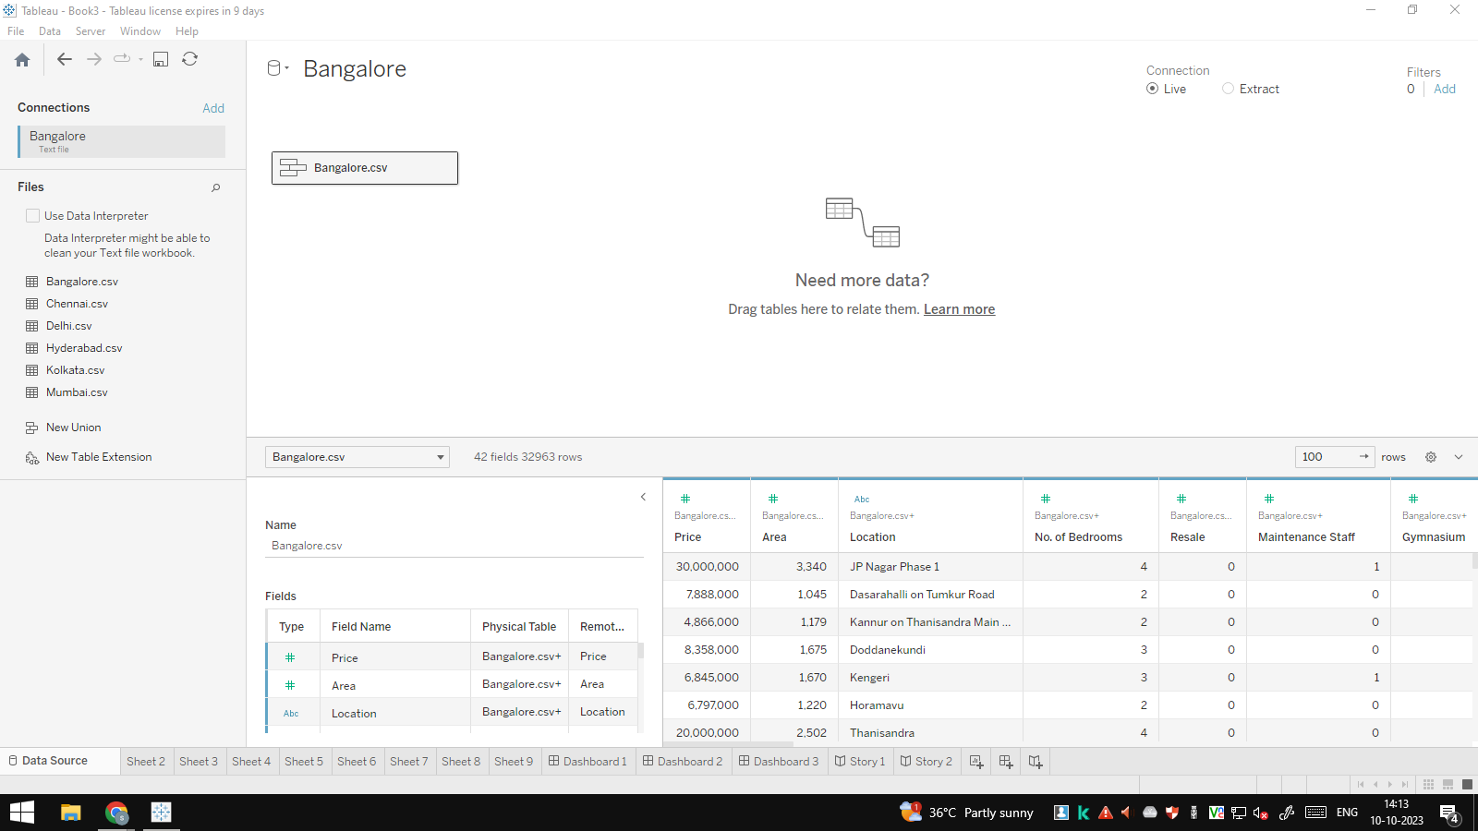

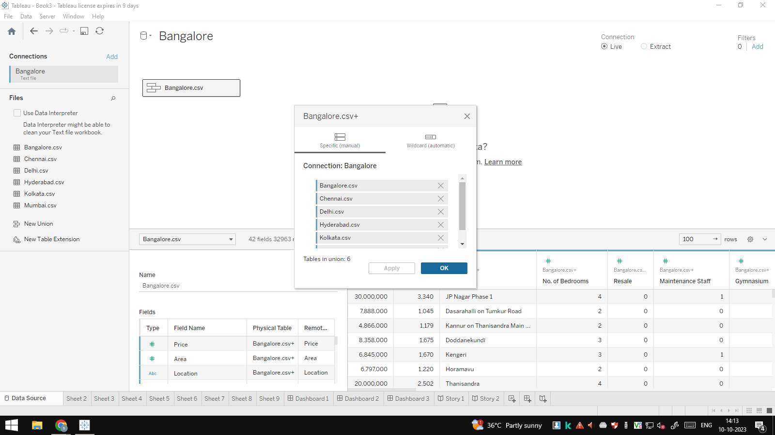

**Prices of Houses based on Area :**

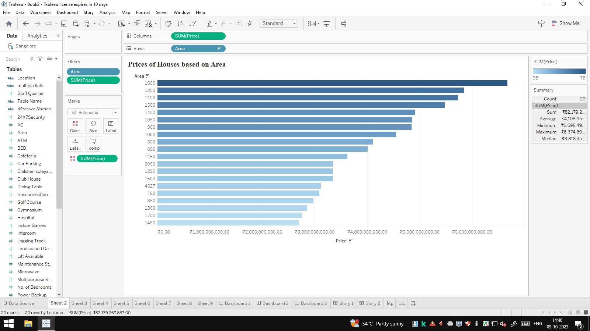

**House Price based on Rain Water pits:**

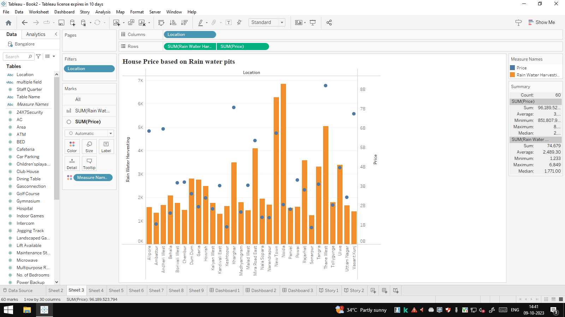

**Vastu – Complaints based on location:**

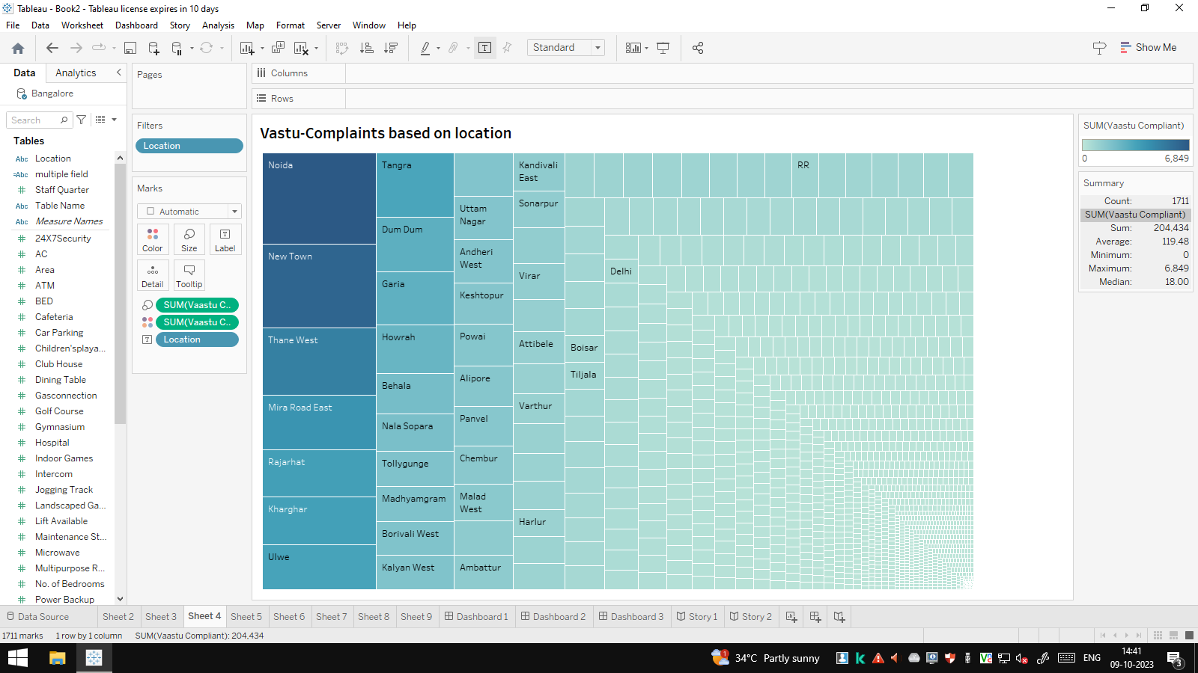

**House price based on Number of Bedrooms :**

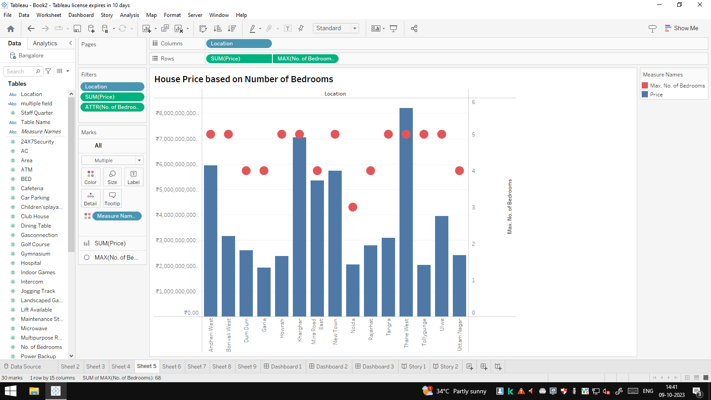

**House price based on nearby schools and hospitals:**

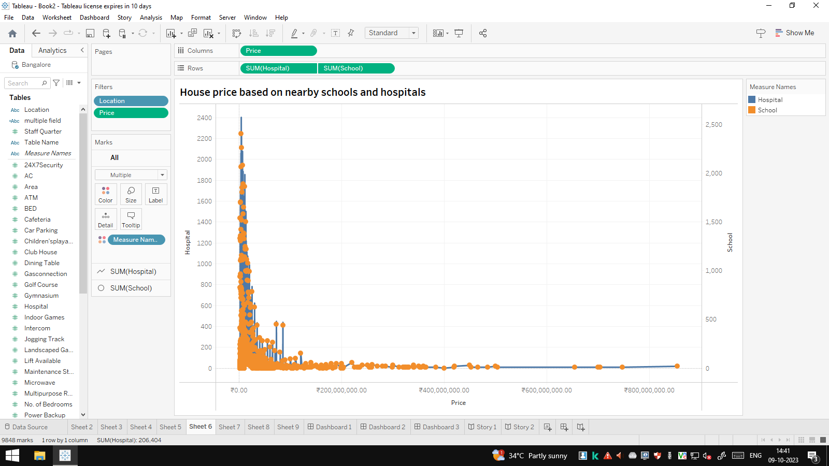

**Maintain staff in houses prices:**

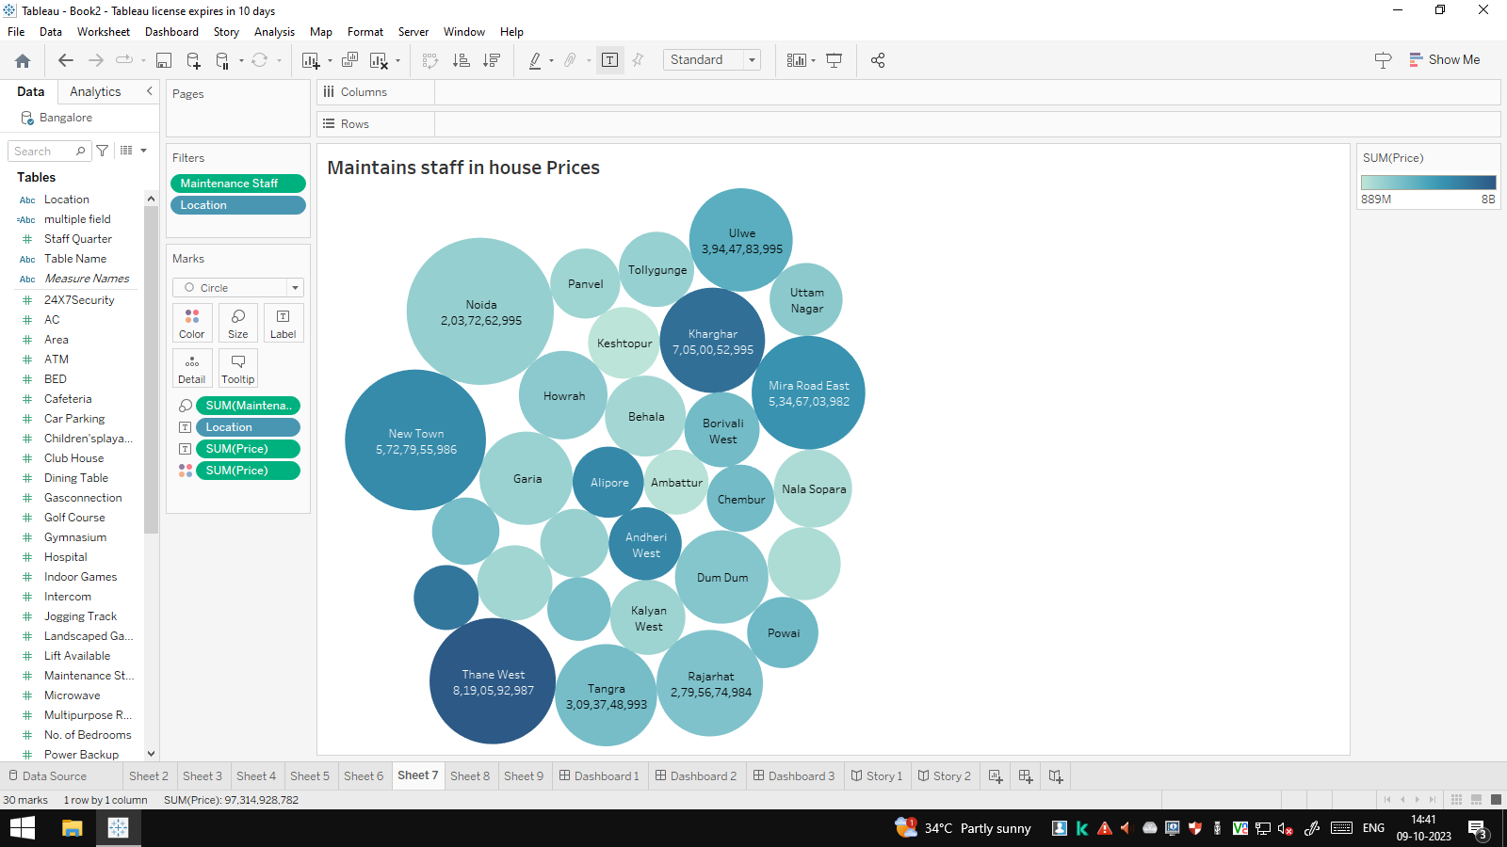

**House Price and Intercom:**

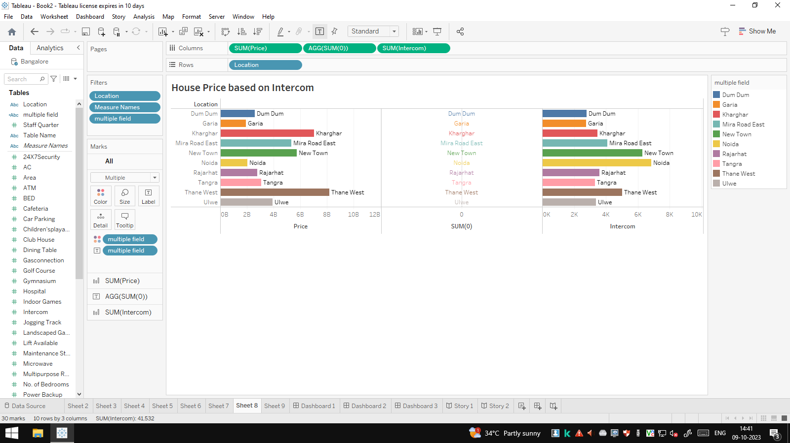

**All services based on locations:**

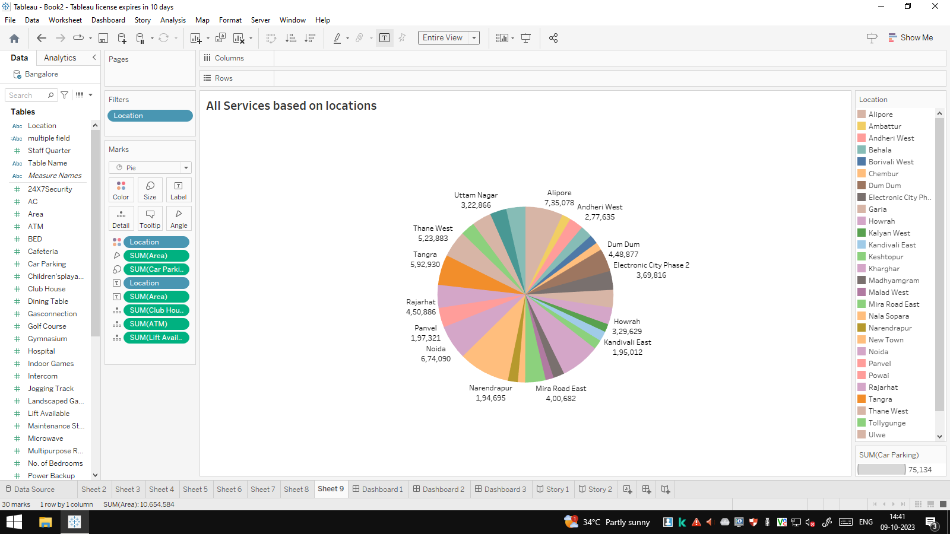

**Dashboard 1:**

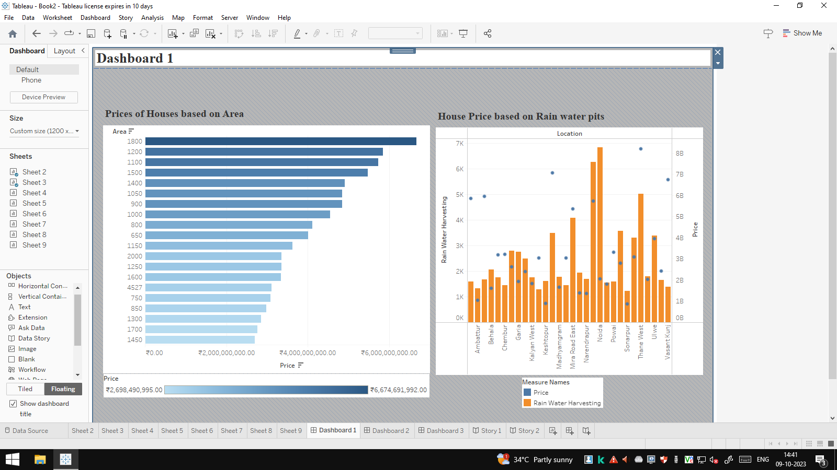

**Dash board 2:**

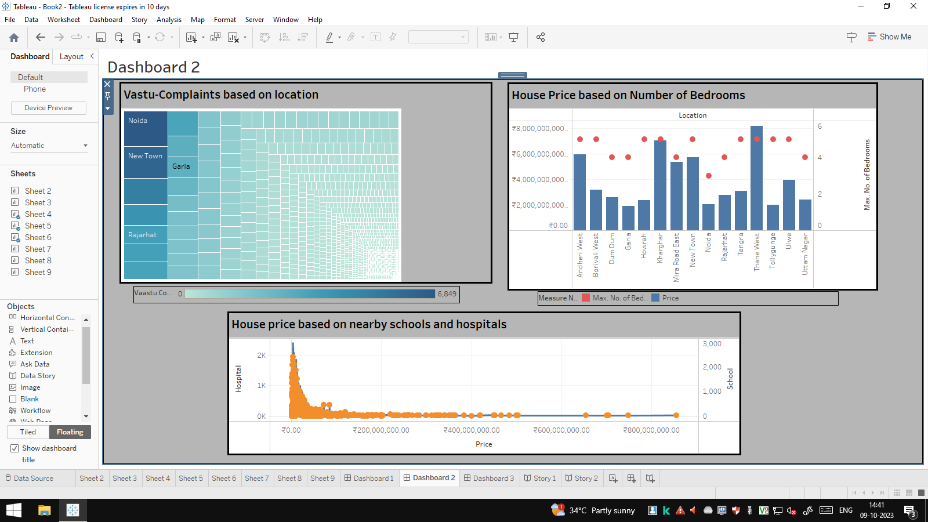

**Dashboard 3:**

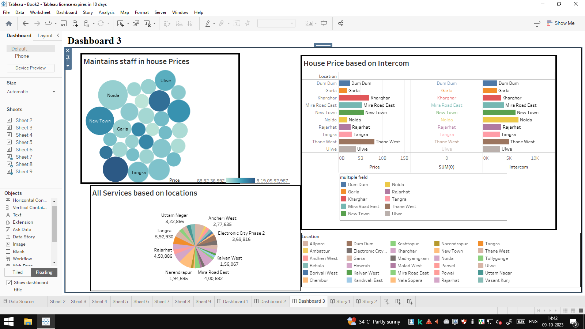

**Story 1:**

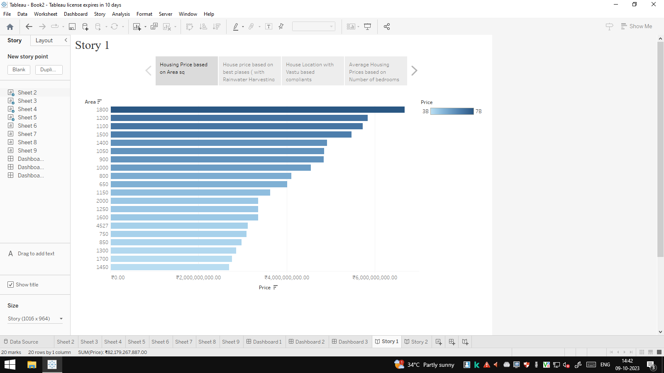

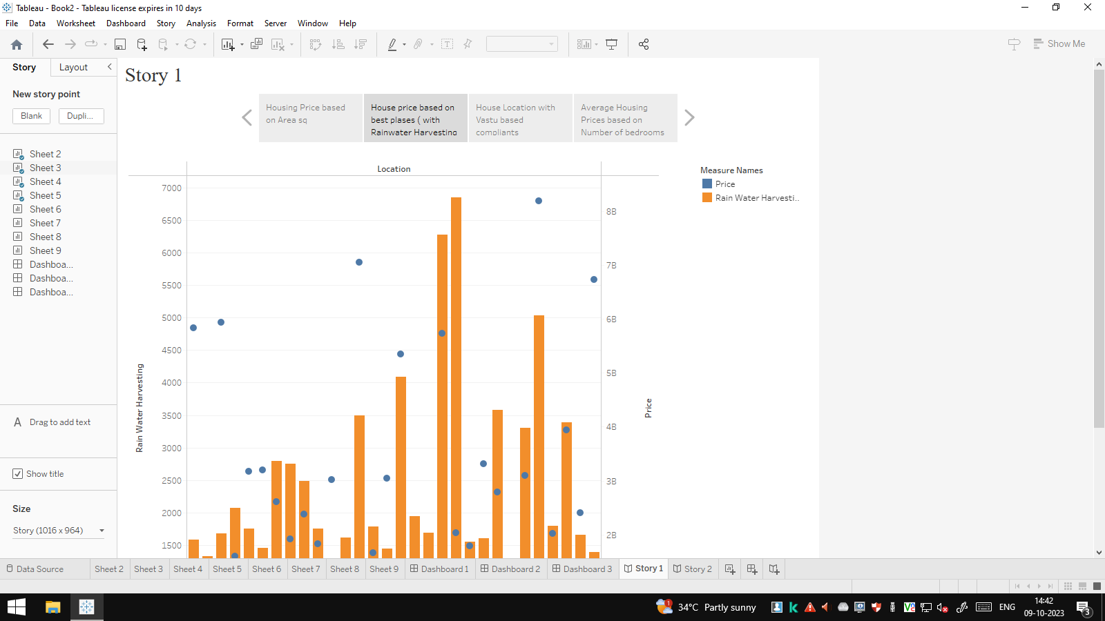

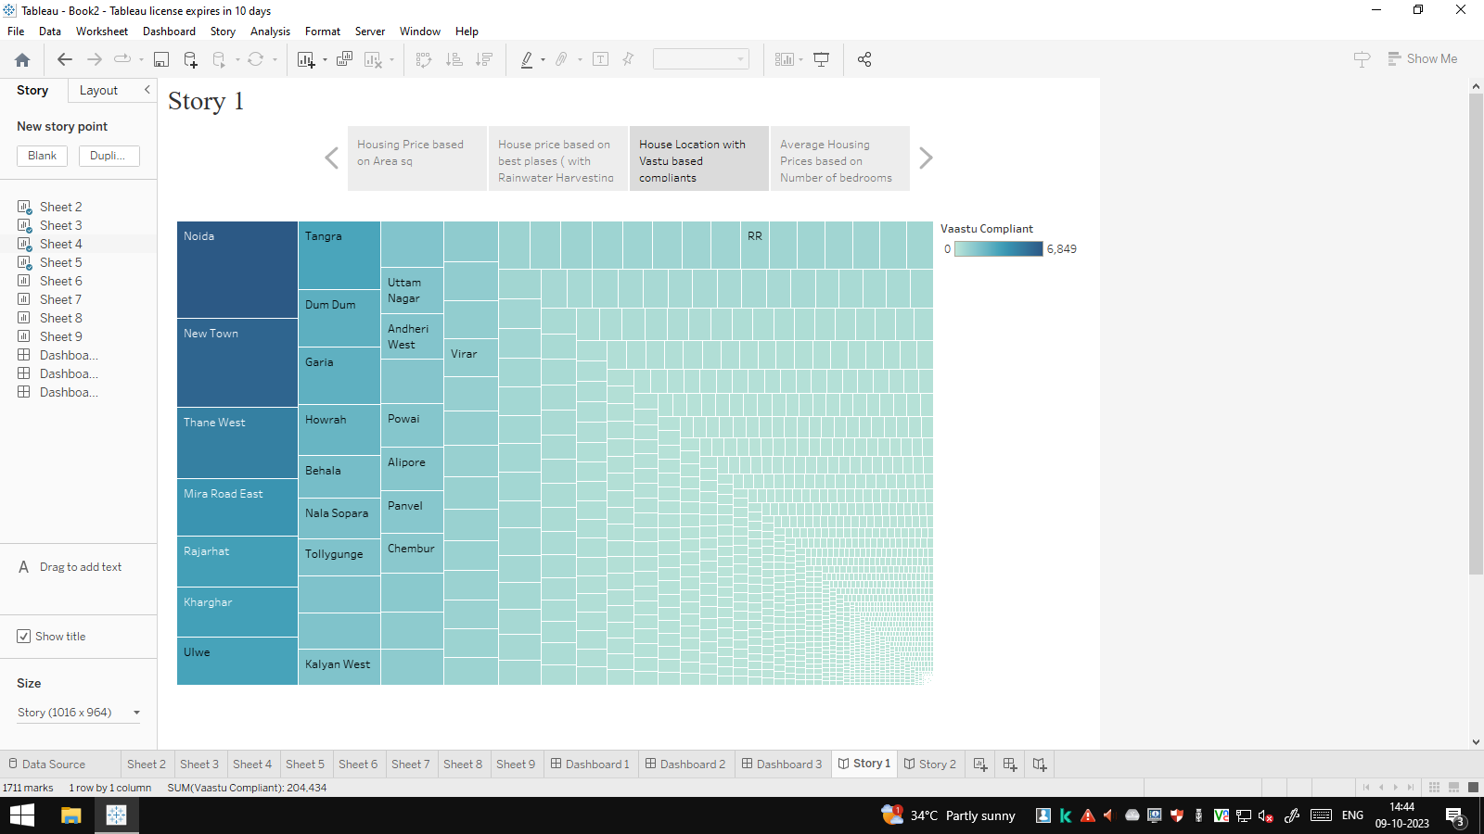

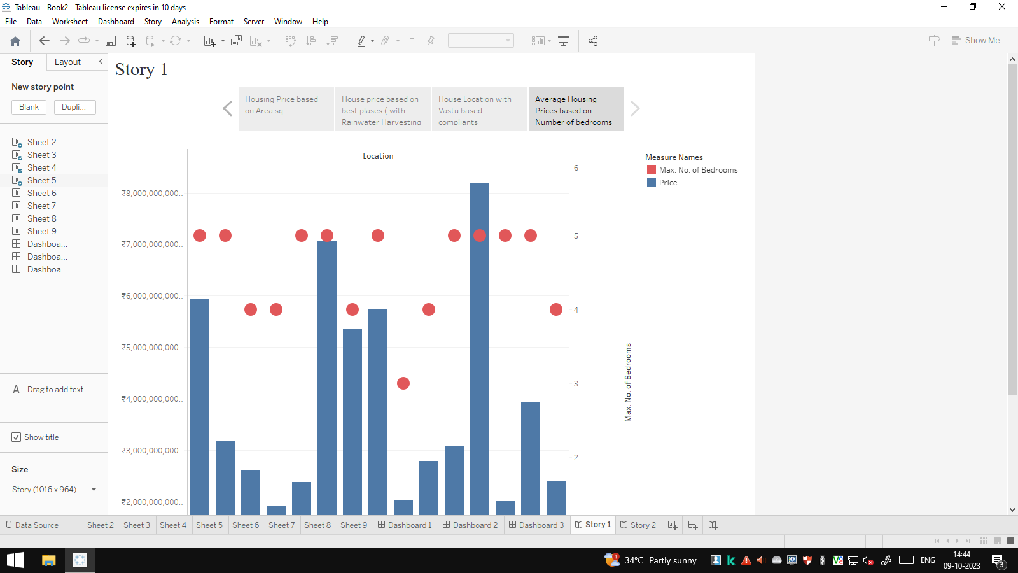

**Story 2:**

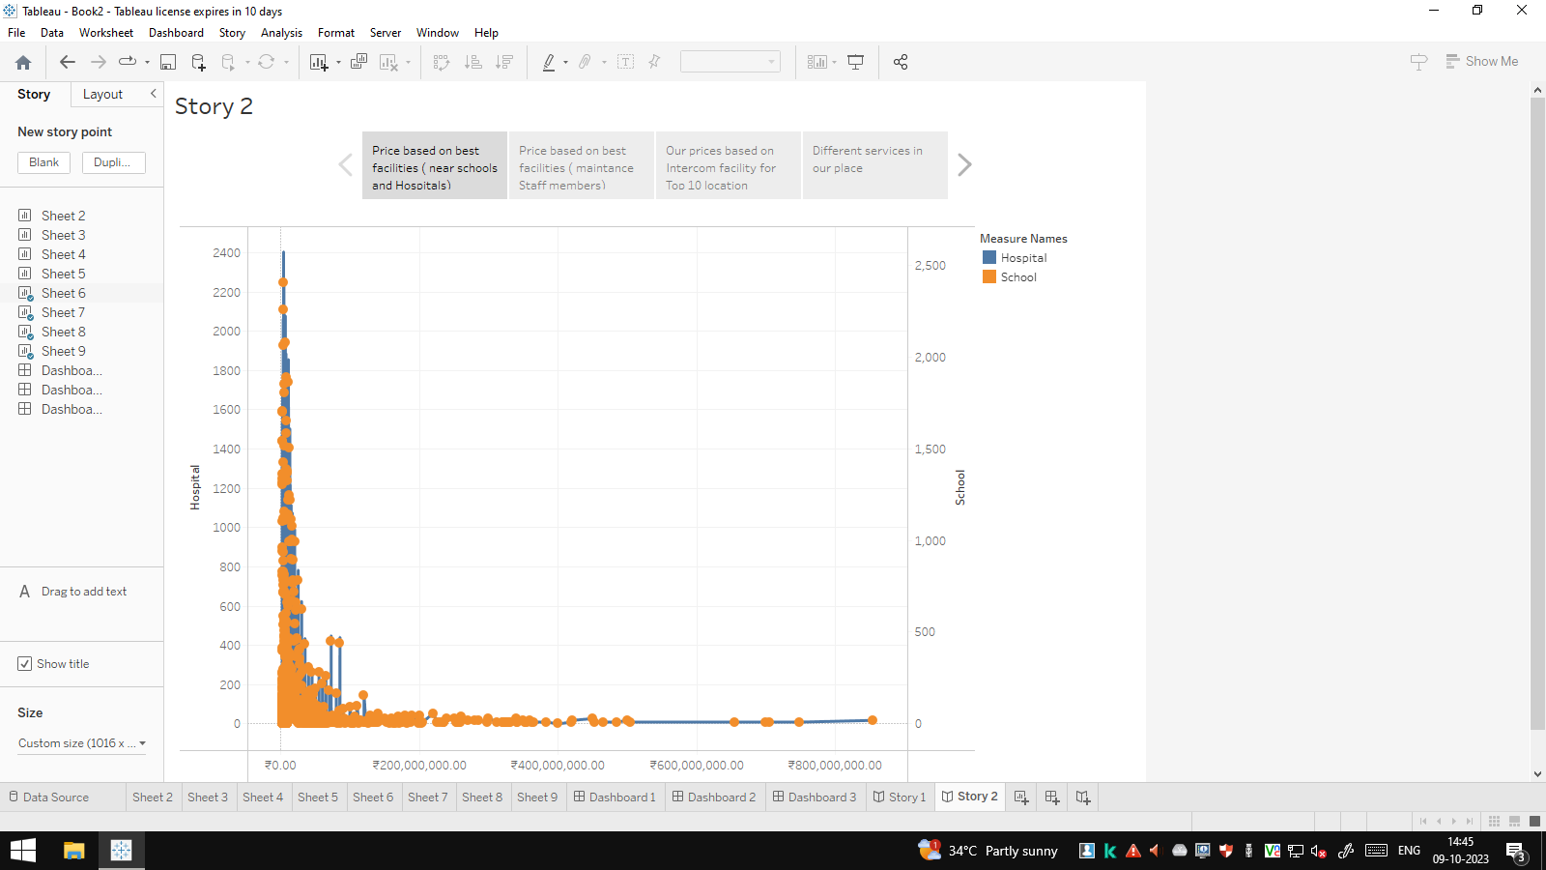

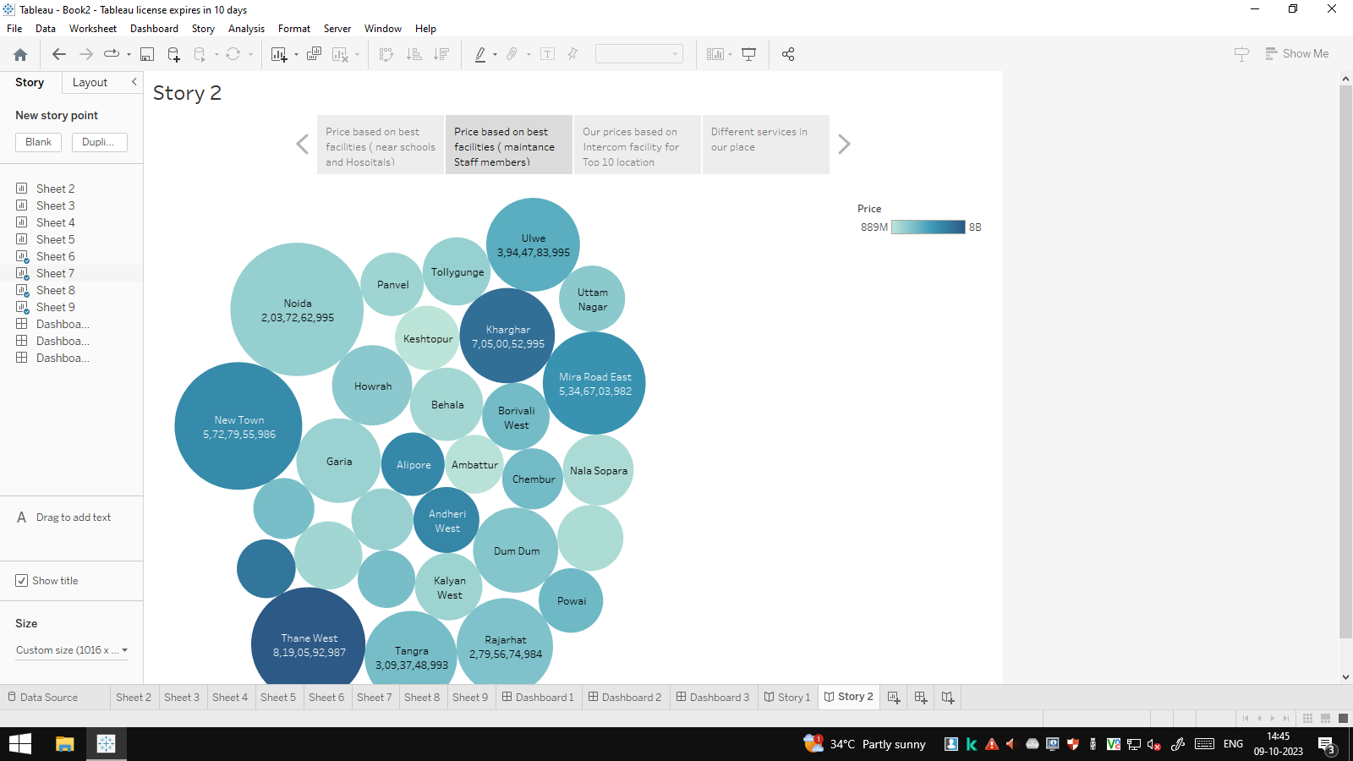

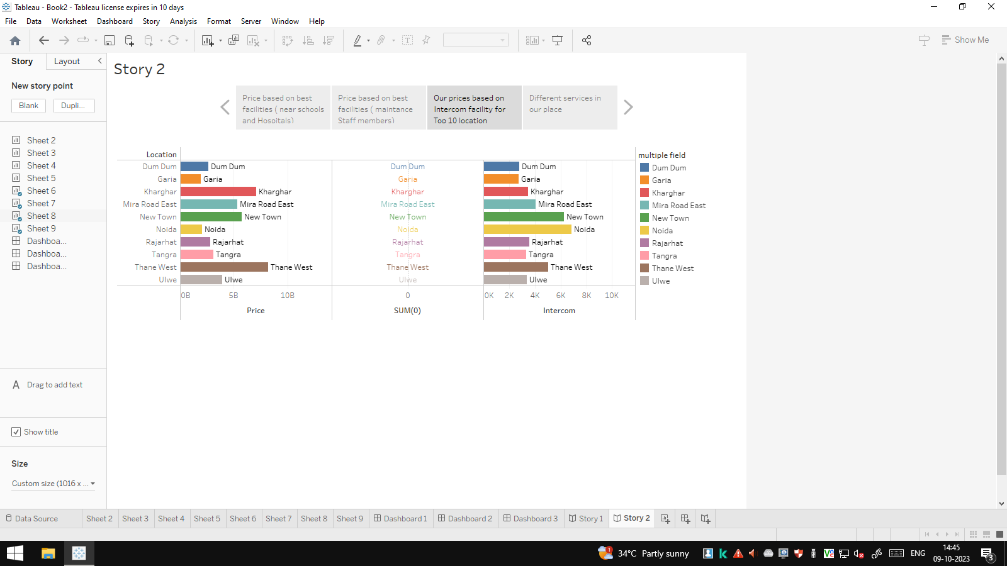

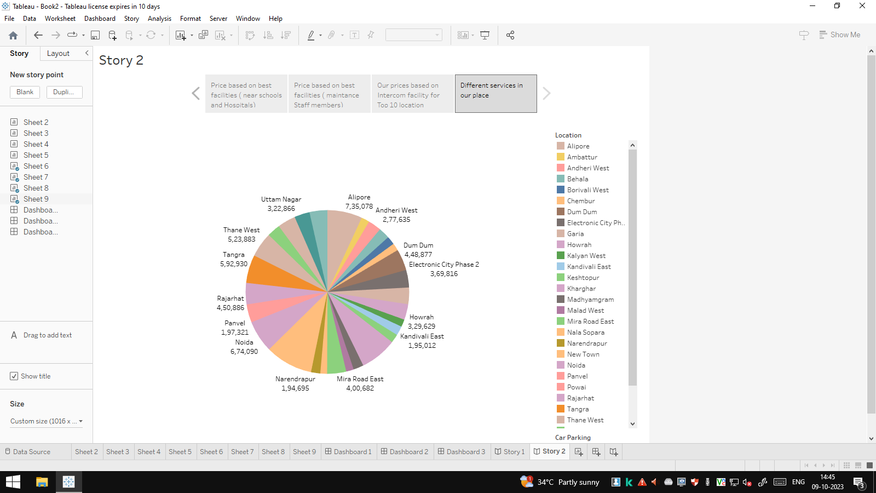

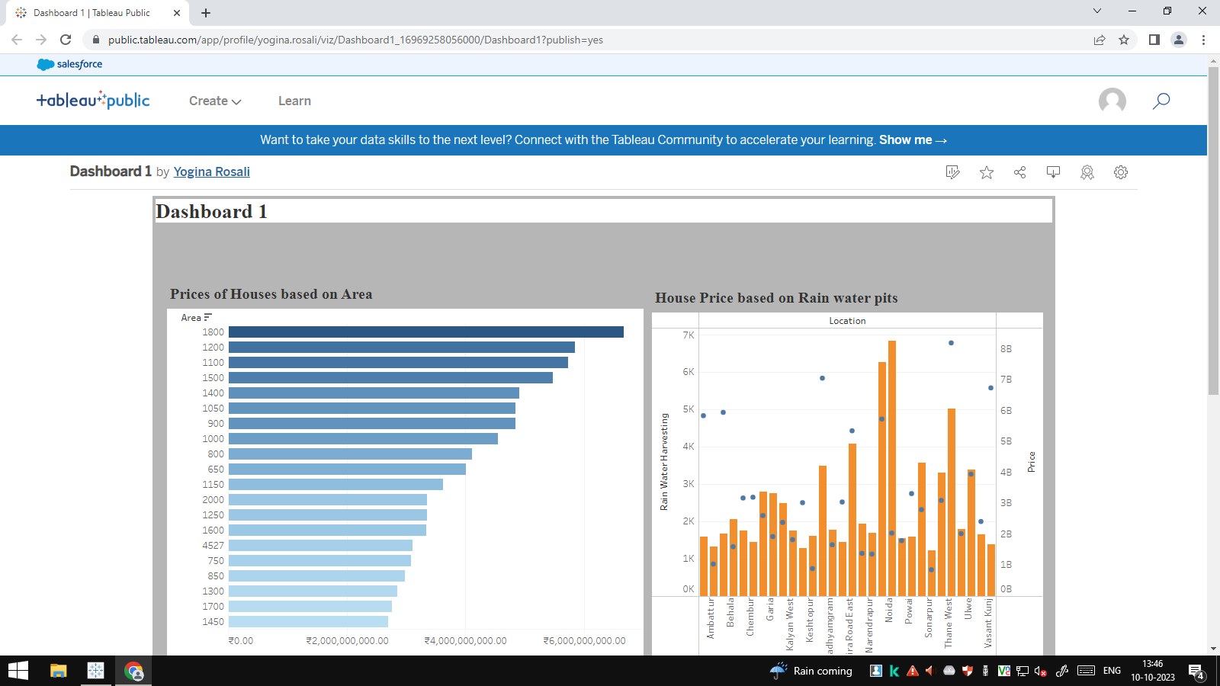

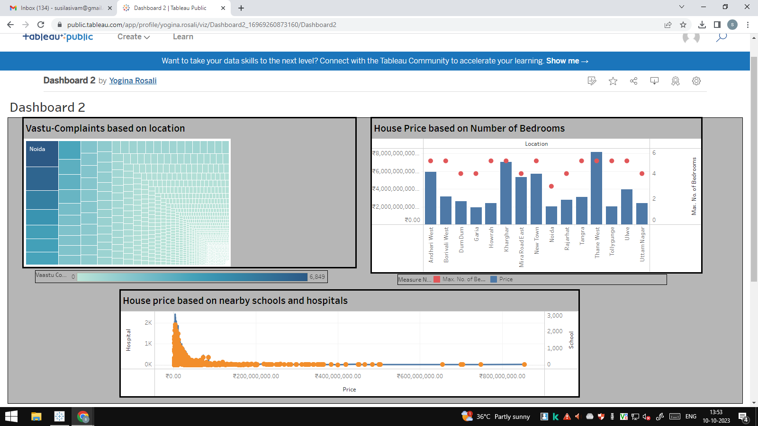

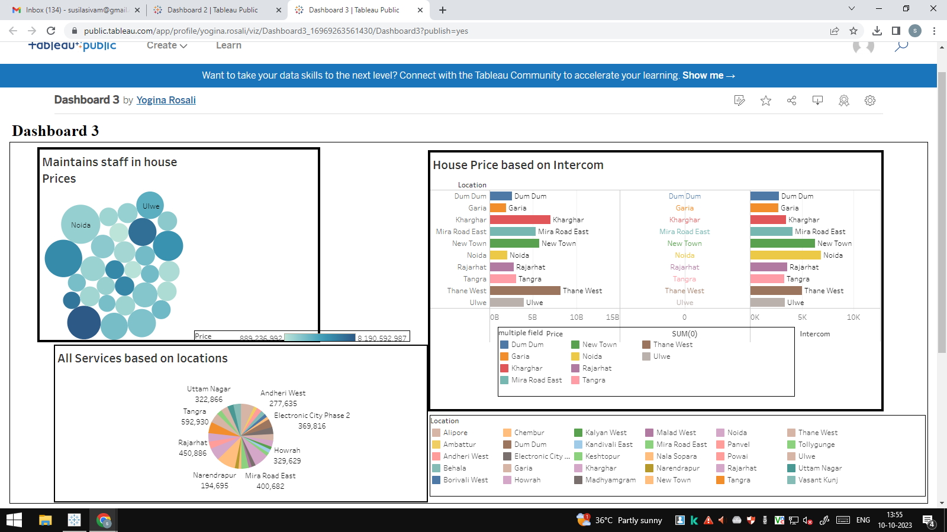

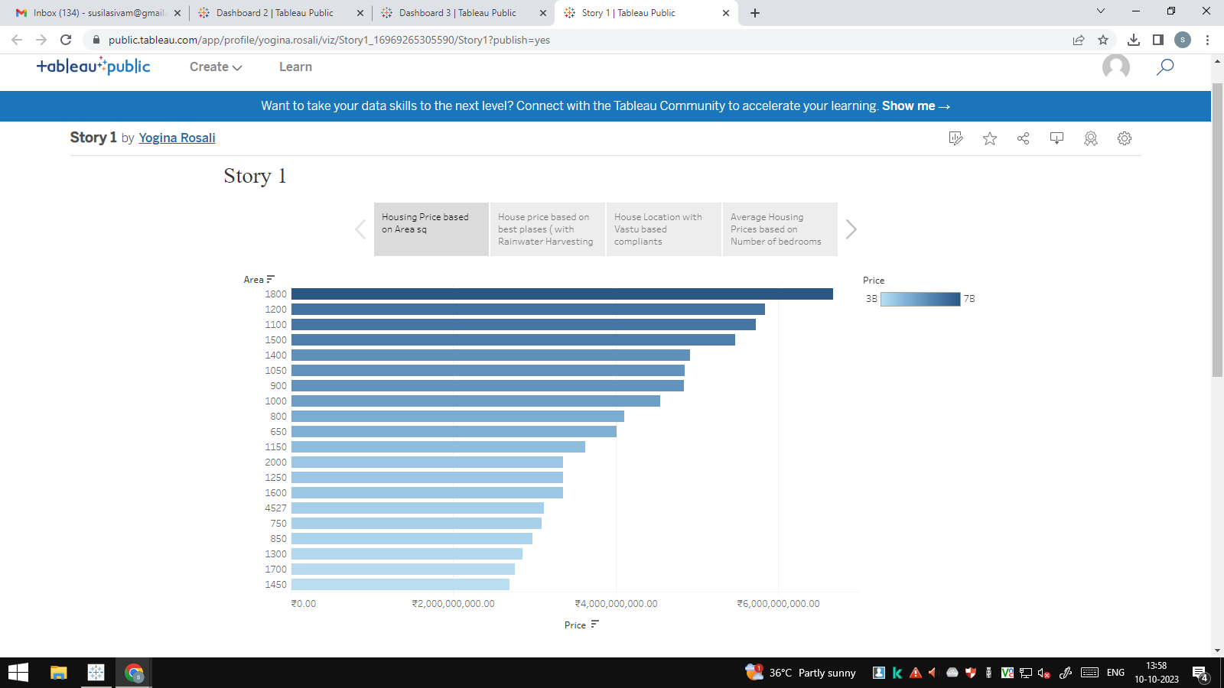

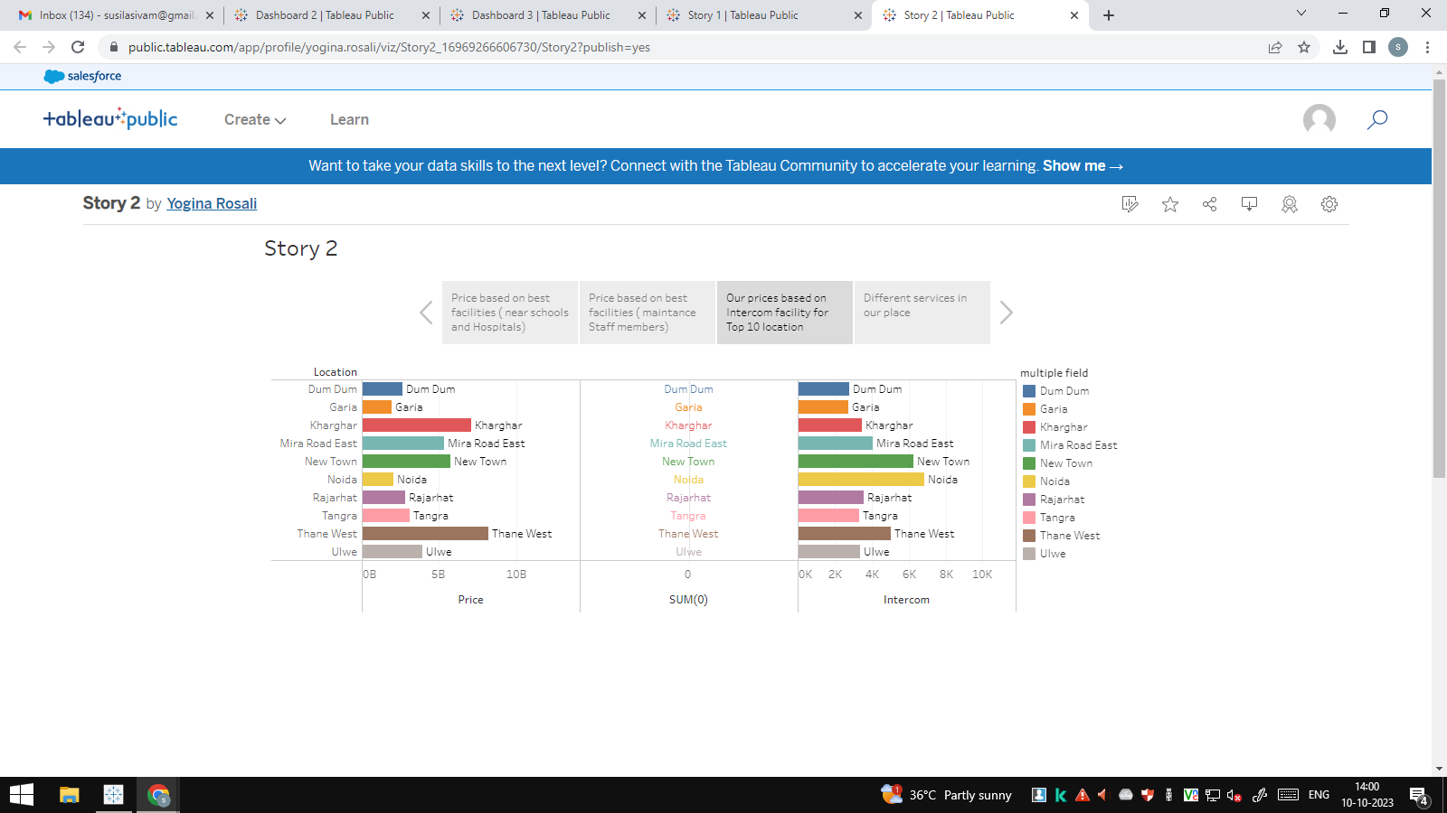

**4. Advantages :**

* **Market Transparency:**

**Regular analysis of housing prices promotes transparency in the real estate market, reducing the likelihood of fraudulent practices.**

* **Economic Growth:**

**A stable and thriving real estate market can stimulate economic growth market can stimulate economic growth, creating jobs and driving investments in related industries.**

* **Quality of Life:**

**Access to suitable housing enhances the overall quality of life for residents, contributing to their well being and satisfaction.**

**Disadvantages:**

* **Inequality:**

**Housing price disparitites can exacerbate wealth and income inequality, creating social and economic challenges.**

* **Exclusionary Effects:**

**Rapid price increases can lead to gentrification, pushing out lower income residents from desirable neighborhoods.**

* **Environmental Impact:**

**Unsustainable housing practices driven by prices trends can harm the environment through excessive resource consumption and urban sprawl.**

1. **Application.**

* **Homebuying Decisions:**

**Prospective homebuyers rely on housing price data to assess affordability, choode suitable neighborhoods, and neggotiate prices when purchasing homes.**

* **Rent Estimation:**

**Landlords and tenants can use housing price trends to estimate fair rental rates, ensuring both parties are getting a reasonable deal**

* **Government Revenue Estimation:**

**Property taxes are often based on the assessed value of real estate, which can be influenced by housing prices.**

* **Housing Market Forecasting:**

**Forecasting future housing price trends helps businesses and individuals make long term financial plans.**

1. **Conclusion:**

**ln conclusion, the analysis of housing prices in metropolitan areas serves as a multifunctional tool with wide ranging applications. It plays a pivot role in shaping urban landscapes, economic development, and individual choices, while also serving as a critical resource for policymakers and researchers. Recognizing the advantages and challenges associated with housing price analysis allows for more informed and responsible decision making in the complex world of real estate and urban development. The examination of housing prices serves as a vital tool for understanding the dyn market and itamics of the real estate market and its broader impact on society and the economy.**

1. **Future scope:**

**In the future, several enhancements and improvements can be made in the effective. Some potential enhancements include, Advanced Data Sources, Machine Learning and AI, Real Time Data, Predictive Analytics, Visualization Tools, Integration with Other Data, Affordability Metrics, Mobile Apps. These enhancement can help make housing price analysis more accurate, relevant, and beneficial for a broader range of stakeholders, ultimately contributing to more informed decision making, equitable urban development and sustainable housing solutions in metropolitan area.**